**Media Streaming with IBM Cloud Video Streaming**

**Phase 3 submission**

**Introduction:**

Media streaming is an integral part of the modern digital landscape, revolutionizing the way we consume and share content. IBM Cloud Video Streaming, a powerful and versatile platform offered by IBM, has emerged as a frontrunner in this domain. As the demand for high-quality video content continues to grow, IBM Cloud Video Streaming provides a comprehensive solution for individuals and businesses alike, allowing them to deliver, manage, and optimize their video content efficiently and effectively.

IBM Cloud Video Streaming is designed to meet the diverse needs of its users. Whether you are a content creator, an enterprise looking to engage with your audience, or an educational institution seeking to reach a broader student base, this platform offers a tailored solution. It enables users to seamlessly stream live events, webinars, on-demand videos, and more. With IBM Cloud Video Streaming, you can engage your audience in real-time, create interactive live experiences, and archive content for future viewing.

One of the standout features of IBM Cloud Video Streaming is its robust and scalable infrastructure. It leverages IBM's extensive global network and data centers to ensure high-quality streaming, even in regions with limited connectivity. This ensures that your content is accessible to audiences worldwide, offering a seamless and buffer-free viewing experience. Additionally, the platform provides advanced analytics and monitoring tools, allowing users to gain valuable insights into their viewers' behavior, thus optimizing content delivery and engagement strategies.

Furthermore, security is a top priority in today's digital landscape. IBM Cloud Video Streaming prioritizes the protection of your content and data. It offers various security features, including password protection, encryption, and secure embed options to safeguard your video streams. In an era where data privacy is paramount, IBM's commitment to security ensures that your content remains protected from unauthorized access or breaches.

In conclusion, IBM Cloud Video Streaming empowers individuals, businesses, and organizations to harness the power of media streaming in the digital age. With its user-friendly interface, scalability, and commitment to security, it provides a comprehensive solution for all your video streaming needs. Whether you're a content creator looking to reach a global audience or an enterprise seeking to engage customers, IBM Cloud Video Streaming is a robust platform that offers the tools and capabilities to make your content streaming experience a success.

**Pre-processing**

In this notebook, we will pre-process the frames. For better visualisation, we will just capture 2 frames and visualise all the steps. The steps are:

1. Capture 2 consecutive frames.
2. Find difference between the frames to capture the motion.
3. Use GaussianBlur, thresholding, dilation and erosion to pre-process the frames.
4. Image segmentation using contours. Extract the vehicles during this method.
5. Convert contours to hulls.

*# Run these if OpenCV doesn't load*

import sys

# sys.path.append('/Library/Frameworks/Python.framework/Versions/3.6/lib/python3.6/site-packages/cv2/')

**Import the necessary libraries**

First, we import the necessary libraries

import cv2

import numpy as np

import math

import matplotlib.pyplot as plt

%matplotlib inline

**Defining the variables**

Next, we define variables that will be used through the duration of the code

# Here, we define some colours

SCALAR_BLACK = (0.0,0.0,0.0)

SCALAR_WHITE = (255.0,255.0,255.0)

SCALAR_YELLOW = (0.0,255.0,255.0)

SCALAR_GREEN = (0.0,255.0,0.0)

SCALAR_RED = (0.0,0.0,255.0)

SCALAR_CYAN = (255.0,255.0,0.0)

**Function to draw the image**

# function to plot n images using subplots

def plot_image(images, captions=None, cmap=None ):

f, axes = plt.subplots(1, len(images), sharey=True)

f.set_figwidth(15)

for ax,image,caption **in** zip(axes, images, captions):

ax.imshow(image, cmap)

ax.set_title(caption)

### Capturing movement in video

**Two consecutive frames are required to capture the movement**. If there is movement in vehicle, there will be small change in pixel value in the current frame compared to the previous frame. The change implies movement. Let's capture the first 2 frames now.

SHOW_DEBUG_STEPS = True

**# Reading video**

cap = cv2.VideoCapture('../input/video-analysis/AundhBridge.mp4')

*# if video is not present, show error*

if **not**(cap.isOpened()):

print("Error reading file")

**# Check if you are able to capture the video**

ret, fFrame = cap.read()

*# Capturing 2 consecutive frames and making a copy of those frame. Perform all operations on the copy frame.*

ret, fFrame1 = cap.read()

ret, fFrame2 = cap.read()

img1 = fFrame1.copy()

img2 = fFrame2.copy()

if(SHOW_DEBUG_STEPS):

print ('img1 height' + str(img1.shape[0]))

print ('img1 width' + str(img1.shape[1]))

print ('img2 height' + str(img2.shape[0]))

print ('img2 width' + str(img2.shape[1]))

**# Convert the colour images to greyscale in order to enable fast processing**

img1 = cv2.cvtColor(img1, cv2.COLOR_BGR2GRAY)

img2 = cv2.cvtColor(img2, cv2.COLOR_BGR2GRAY)

plot_image([img1, img2], cmap='gray', captions=["First frame", "Second frame"])

**#plotting**

img1 height720

img1 width1280

img2 height720

img2 width1280

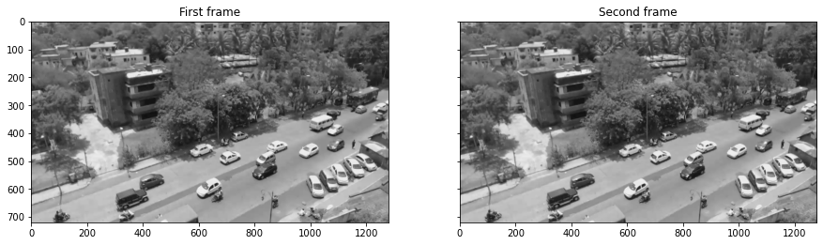

### Adding gaussion blur for smoothening

*# Add some Gaussian Blur*

img1 = cv2.GaussianBlur(img1,(5,5),0)

img2 = cv2.GaussianBlur(img2,(5,5),0)

*#plotting*

plot_image([img1, img2], cmap='gray', captions=["GaussianBlur first frame", "GaussianBlur second frame"])

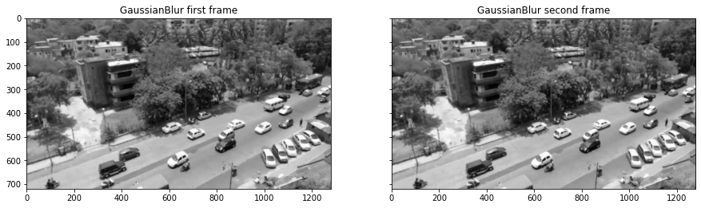

### Find the movement in video

If vehicle is moving, there will be **slight change** in pixel value in the next frame compared to previous frame. We then threshold the image. This will be useful further for preprocessing. Pixel value below 30 will be set as 0(black) and above as 255(white)

Thresholding: <https://docs.opencv.org/3.0-beta/doc/py_tutorials/py_imgproc/py_thresholding/py_thresholding.html>

# This imgDiff variable is the difference between consecutive frames, which is equivalent to detecting

Movement

imgDiff = cv2.absdiff(img1, img2)

# Thresholding the image that is obtained after taking difference. Pixel value below 30 will be set as 0(black)and above as 255(white*)*

ret,imgThresh = cv2.threshold(imgDiff,30.0,255.0,cv2.THRESH_BINARY)

ht = np.size(imgThresh,0)

wd = np.size(imgThresh,1)

plot_image([imgDiff, imgThresh], cmap='gray', captions = ["Difference between 2 frames", "Difference between 2 frames after threshold"])

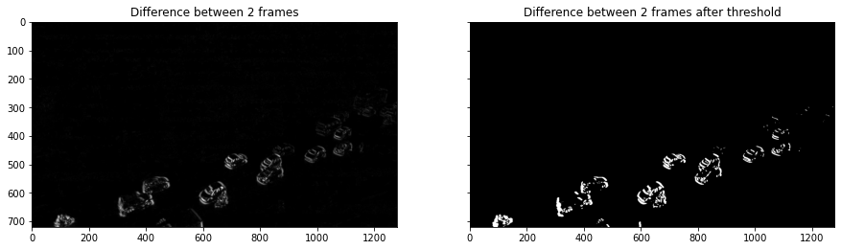 Dilation and erosion in image Dilation and erosion in the image with the filter size of structuring elements.

# Now, we define structuring elements

strucEle3x3 = cv2.getStructuringElement(cv2.MORPH_RECT,(3,3))

strucEle5x5 = cv2.getStructuringElement(cv2.MORPH_RECT,(5,5))

strucEle7x7 = cv2.getStructuringElement(cv2.MORPH_RECT,(7,7))

strucEle15x15 = cv2.getStructuringElement(cv2.MORPH_RECT,(15,15))

plot_image([strucEle3x3, strucEle5x5, strucEle7x7, strucEle15x15], cmap='gray', captions = ["strucEle3x3", "strucEle5x5", "strucEle7x7", "strucEle15x15"])

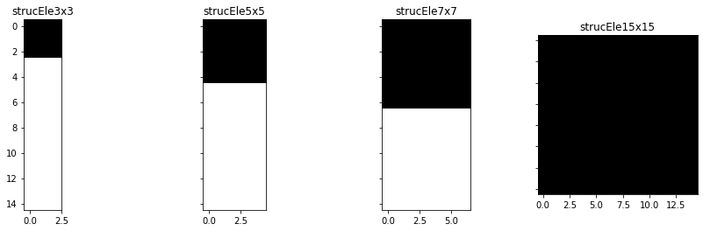

for i **in** range(2):

imgThresh = cv2.dilate(imgThresh,strucEle5x5,iterations = 2)

imgThresh = cv2.erode(imgThresh,strucEle5x5,iterations = 1)

imgThreshCopy = imgThresh.copy()

if(SHOW_DEBUG_STEPS):

print ('imgThreshCopy height' + str(imgThreshCopy.shape[0]))

print ('imgThreshCopy width' + str(imgThreshCopy.shape[1]))

plt.imshow(imgThresh, cmap = 'gray')

plt.show()

imgThreshCopy height720

imgThreshCopy width1280

imgThreshCopy height720

imgThreshCopy width1280

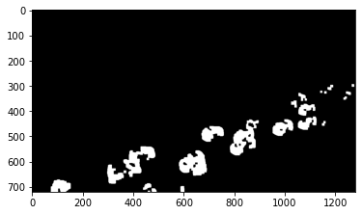

## Extracting contours

Till now, you have a binary image. Next, we will segment the image and find all possible contours(possible vehicles). The shape of the contours will tell us the number of contours that has been identified. Define drawAndShowContours() function to plot the contours. You will see that the threshold image above and the countour image will look alike. So, additionally, we also plot a particular '9th' countour for further clarity.

def drawAndShowContours(wd,ht,contours,strImgName):

global SCALAR_WHITE

global SHOW_DEBUG_STEPS

**Defining a blank frame**

# Defining a blank frame.Since it is initialised with zeros, it will be black. Will add all the coutours in this image.

blank_image = np.zeros((ht,wd,3), np.uint8)

#cv2.drawContours(blank_image,contours,10,SCALAR_WHITE,-1)

# Adding all possible contour to the blank frame. Contour is white

cv2.drawContours(blank_image,contours,-1,SCALAR_WHITE,-1)

*# For better clarity, lets just view countour 9*

blank_image_contour_9 = np.zeros((ht,wd,3), np.uint8)

*# Let's just add contour 9 to the blank image and view it*

cv2.drawContours(blank_image_contour_9,contours,8,SCALAR_WHITE,-1)

*# Plotting*

plot_image([blank_image, blank_image_contour_9], cmap='gray', captions = ["All possible contours", "Only the 9th contour"])

return blank_image

*# Now, we move on to the contour mapping portion*

contours, hierarchy = cv2.findContours(imgThreshCopy,cv2.RETR_EXTERNAL,cv2.CHAIN_APPROX_SIMPLE)

im2 = drawAndShowContours(wd,ht,contours,'imgContours')

*# Printing all the coutours in the image.*

if(SHOW_DEBUG_STEPS):

print ('contours.shape: ' + str(len(contours)))

contours.shape: 22

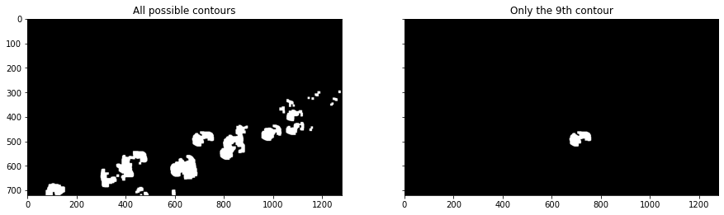

## Hulls

Hulls are contours with the "convexHull".

*# Next, we define hulls.*

*# Hulls are contours with the "convexHull" function from cv2*

hulls = contours *# does it work?*

for i **in** range(len(contours)):

hulls[i] = cv2.convexHull(contours[i])

# Then we draw the contours

im3 = drawAndShowContours(wd,ht,hulls,'imgConvexHulls')

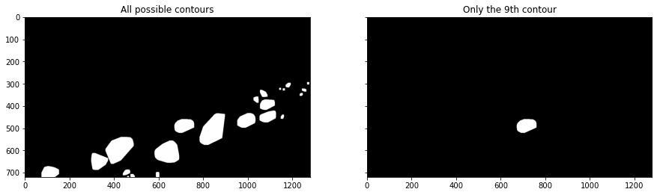

**Conclusion:**

In Phase 3, we've embarked on a transformative journey to develop a cutting-edge virtual cinema platform using IBM Cloud Video Streaming. This phase has been instrumental in shaping the foundational elements of your project.

By defining a comprehensive set of features, you've laid the groundwork for a dynamic and engaging user experience, providing live streaming, video-on-demand, user profiles, interactive chat, content categorization, user engagement tools, payment integration, notifications, and efficient content management.

The intuitive user interface you've designed promises a visually appealing and user-friendly environment, ensuring that users can effortlessly navigate, discover, and interact with content on various devices.

The establishment of user registration and authentication mechanisms underscores your commitment to security and privacy, safeguarding user data and content access.

As you move forward with the development of your virtual cinema platform, it's essential to continue focusing on seamless integration, scalability, and user feedback. This will enable you to refine and enhance the platform, ensuring it meets the evolving demands of your audience and remains a dynamic hub for media streaming.

With Phase 3 complete, we are well on your way to creating a transformative virtual cinema experience that is secure, user-friendly, and packed with features to captivate and connect your audience in the digital age.